**DATABASE ASSIGNMENT**

**SQL QUERIES**

1. ) Student table

CREATE TABLE student(

Rollno int PRIMARY KEY,

Name varchar(50),

Branch varchar(100)

);

CREATE TABLE exam(

S_code varchar(50),

Marks int(11),

P_code varchar(10),

FOREIGN KEY (Rollno) REFERENCES student(Rollno)

);

Student table insertion

INSERT INTO student(Rollno, Name, Branch)

VALUES (1,"Jay", "Computer Science");

INSERT INTO student(Rollno, Name, Branch)

VALUES (2,"Suhani", "Electronic and Communications");

INSERT INTO student(Rollno, Name, Branch)

VALUES (3,"Kriti", "Electronic and Communications");

Exam table insertion

INSERT into exam(Rollno, S_code, Marks, P_code)

VALUES(1, "CS11", 50, "CS");

INSERT into exam(Rollno, S_code, Marks, P_code)

VALUES(1, "CS12", 60, "CS");

INSERT into exam(Rollno, S_code, Marks, P_code)

VALUES(2, "EC101", 66, "EC");

INSERT into exam(Rollno, S_code, Marks, P_code)

VALUES(2, "EC102", 70, "EC");

INSERT into exam(Rollno, S_code, Marks, P_code)

VALUES(3, "EC101", 45, "EC");

INSERT into exam(Rollno, S_code, Marks, P_code)

VALUES(3, "EC102", 50, "EC");

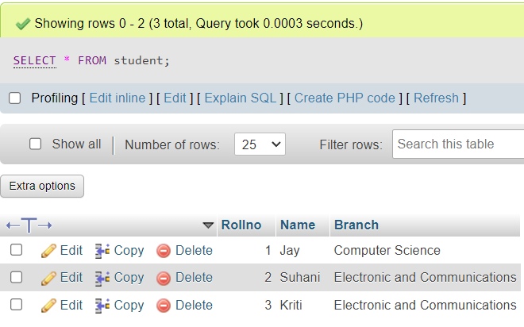

Exam table

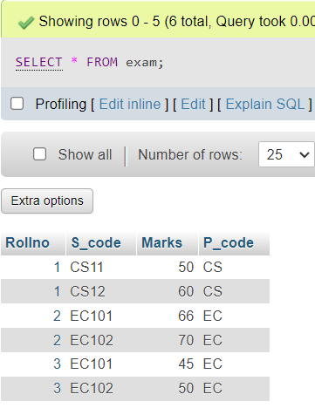

2.)

Employee Table

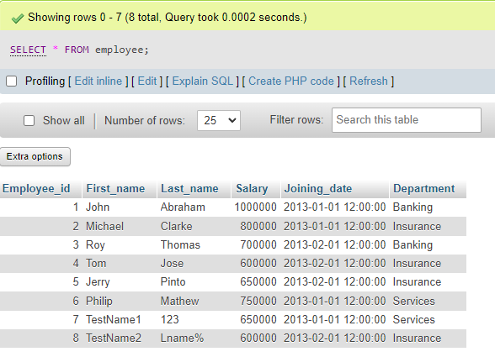

Incentive Table

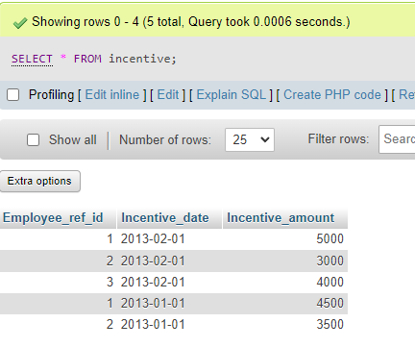

1. Get First_Name from employee table using Tom name “Employee Name”.

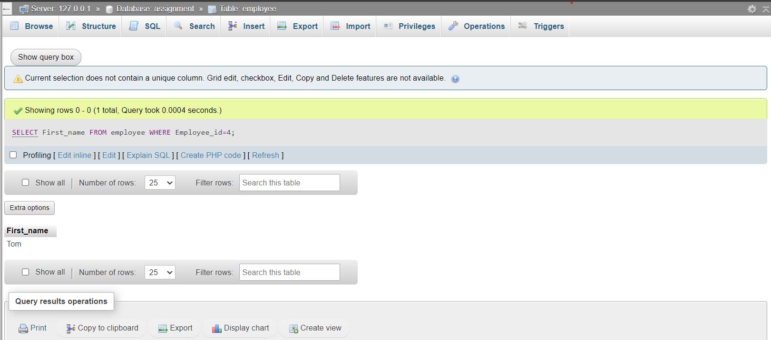

4.Get FIRST_NAME, Joining Date, and Salary from employee table.

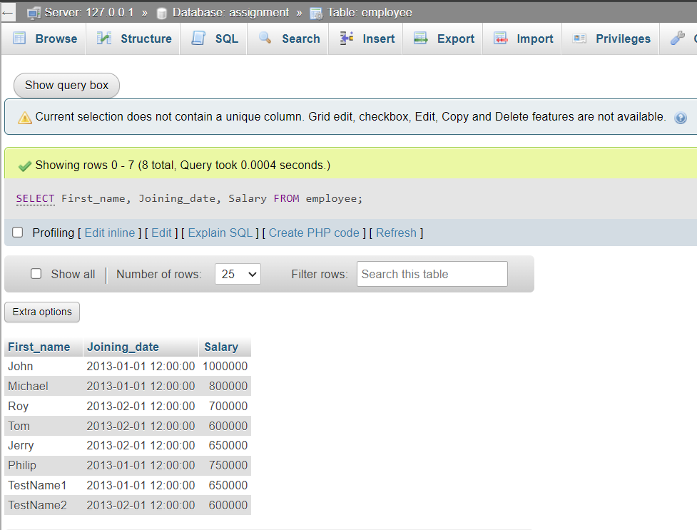

5.Get all employee details from the employee table order by First_Name

Ascending and Salary descending?

First Name Asc

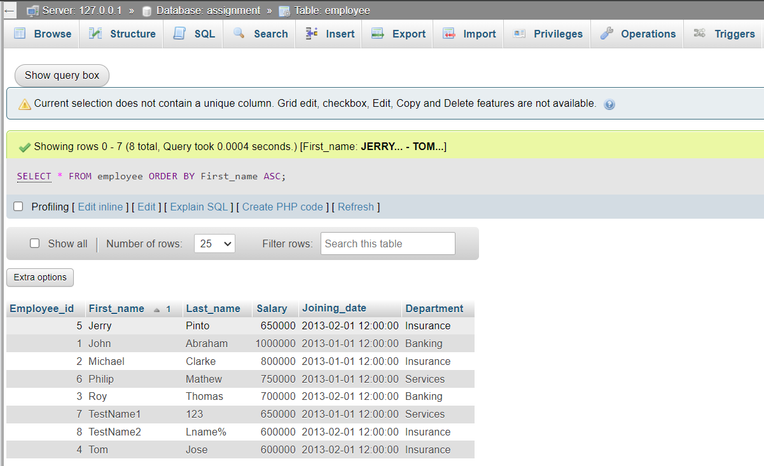

Salary Desc

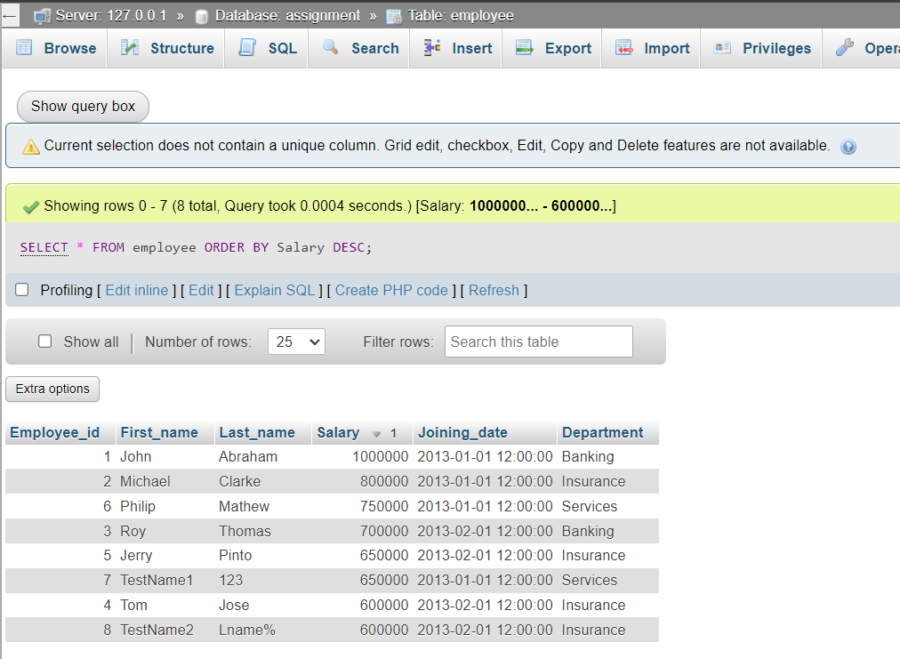

1. Get employee details from employee table whose first name contains ‘J’.

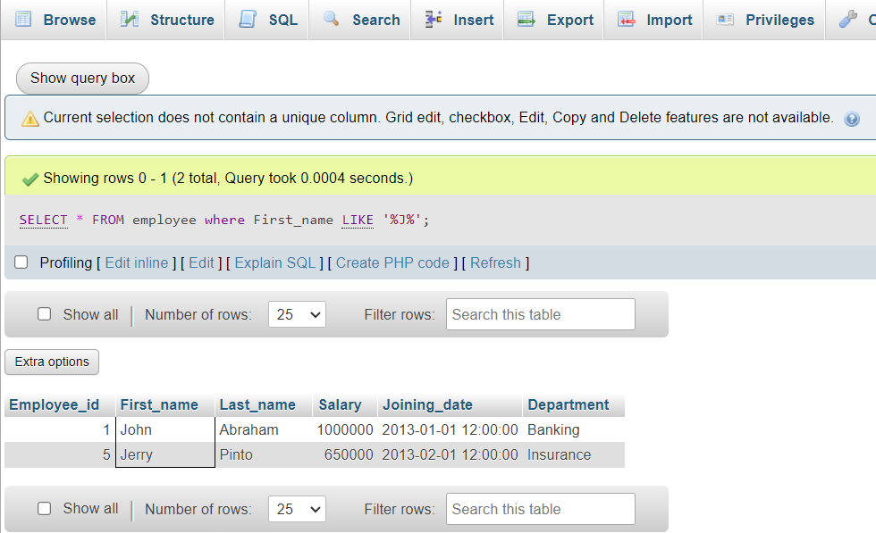

7.Get department wise maximum salary from employee table order by

Salary ascending?

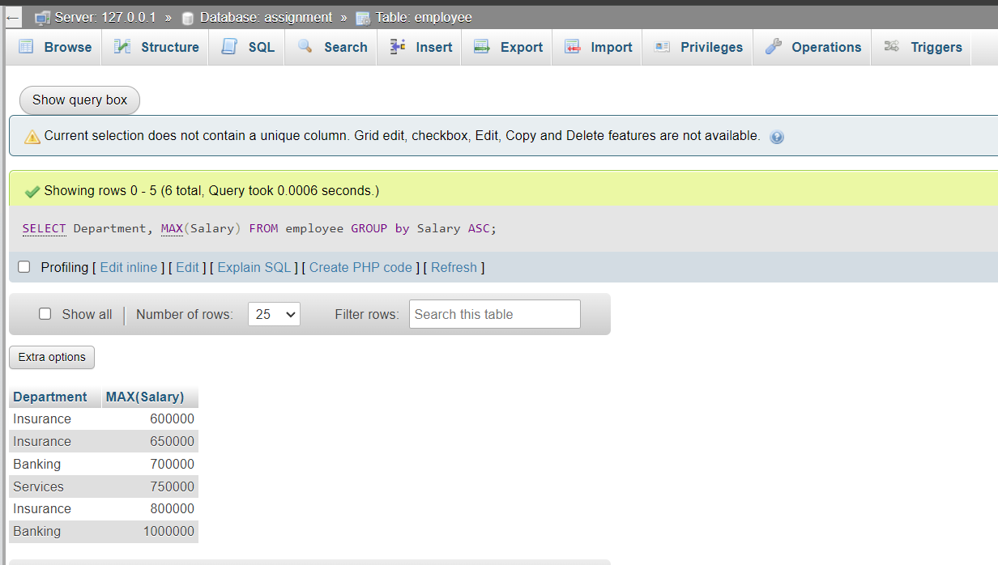

1. Select first_name, incentive amount from employee and incentives table forthose employees who have incentives and incentive amount greater than 3000

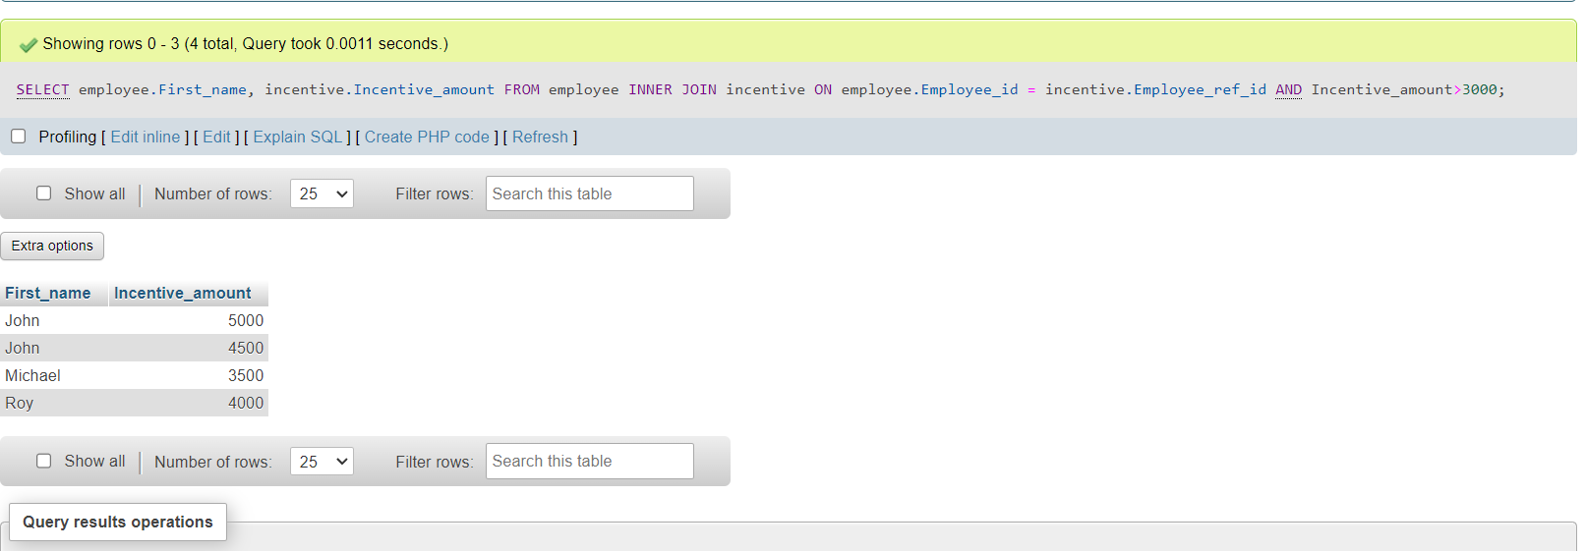

1. Create After Insert trigger on Employee table which insert records in viewtable

DELIMITER

CREATE TRIGGER trg_InsertEmployee

AFTER INSERT

ON employee

FOR EACH ROW

BEGIN

INSERT INTO reminders

VALUES (NEW.employee_id, NEW.First_Name, NEW.Department);

END;

DELIMITER ;

11.)

**Salesperson Table**

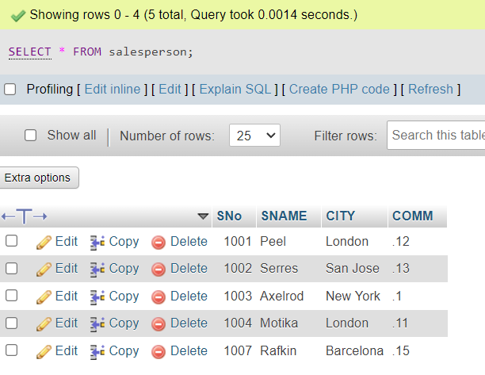

**Customer Table**

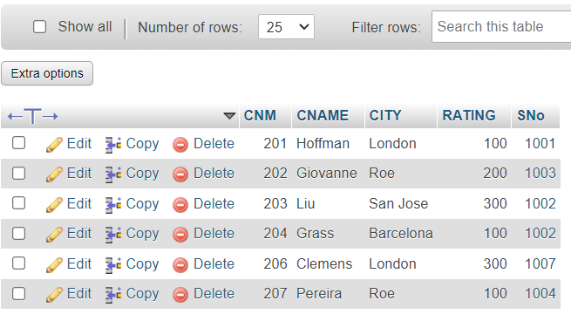

12.Retrieve the below data from above data:-

1. All Customer name whose rating is more than 100.

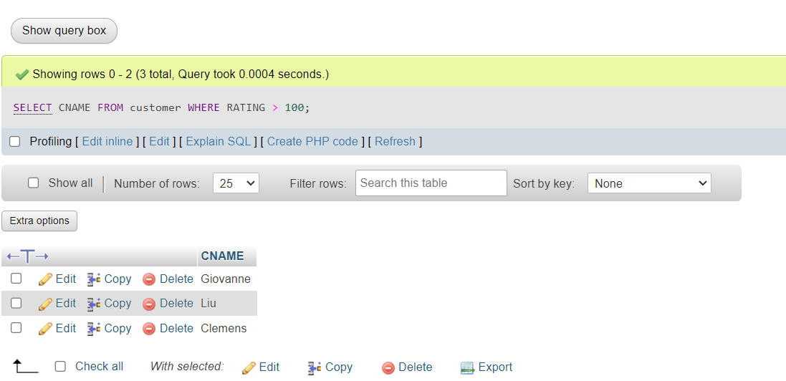

1. Names and cities of all salespeople in London with commission above 0.12

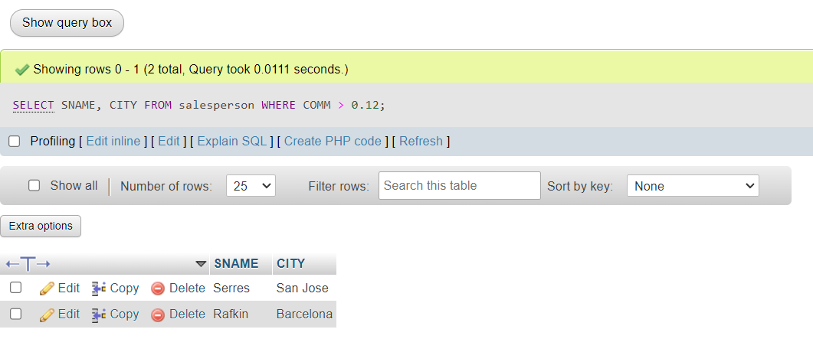

1. All salespeople either in Barcelona or in London

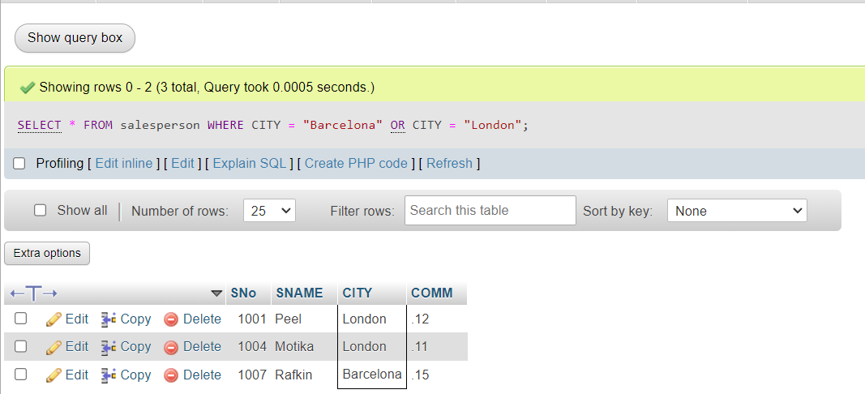

1. All salespeople with commission between 0.10 and 0.12. (Boundary

Values should be excluded).

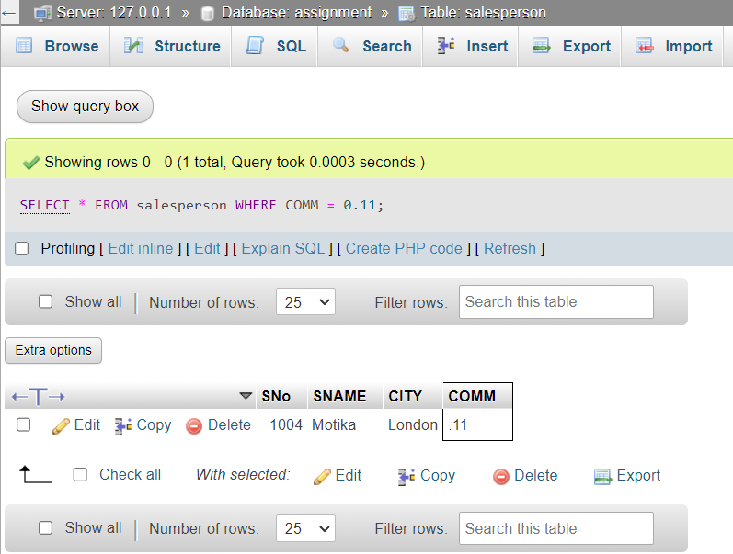

17.All customers excluding those with rating <= 100 unless they are located in Rome

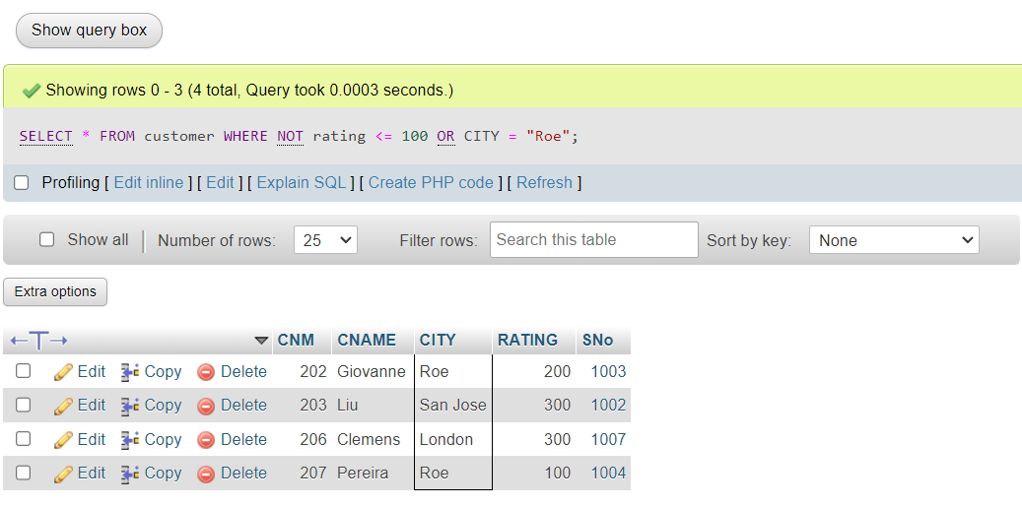

18 )Write a SQL statement that displays all the information about all salespeople

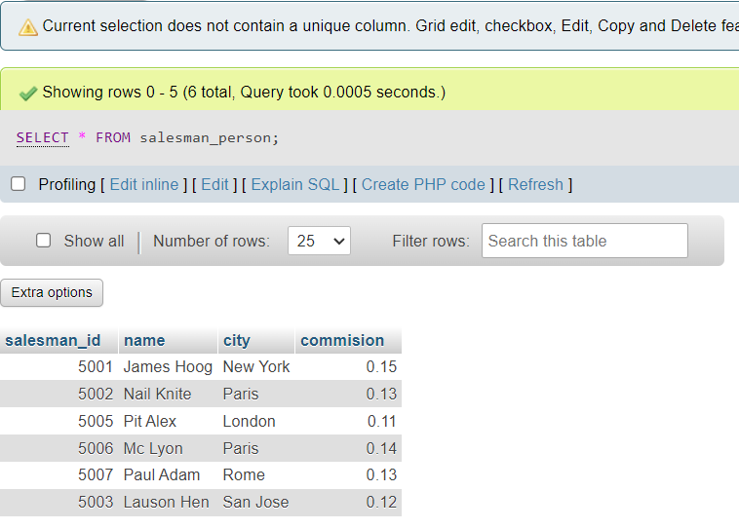

**Orders Table**

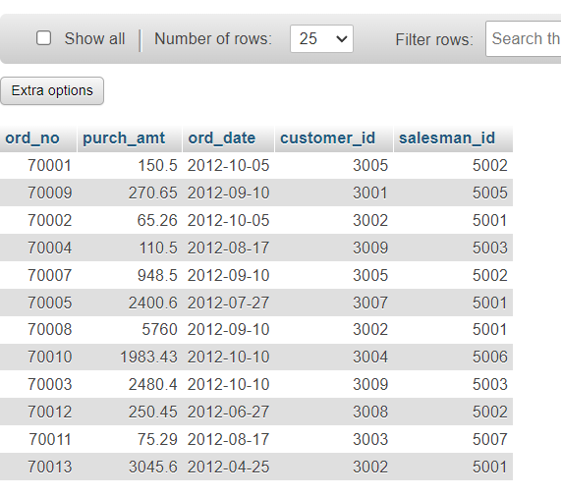

1. From the following table, write a SQL query to find orders that are delivered by a salesperson with ID. 5001. Return ord_no, ord_date, purch_amt.

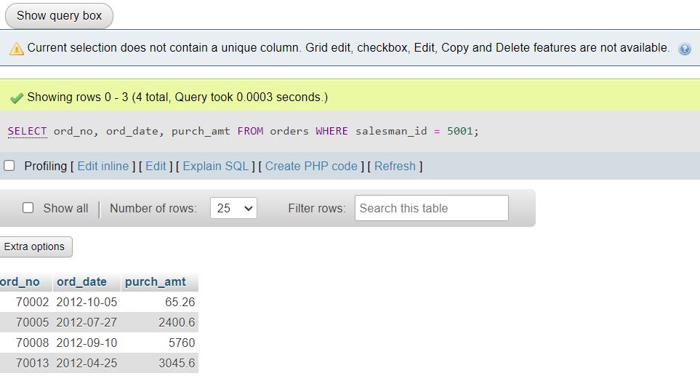

**Item_Mast Table**

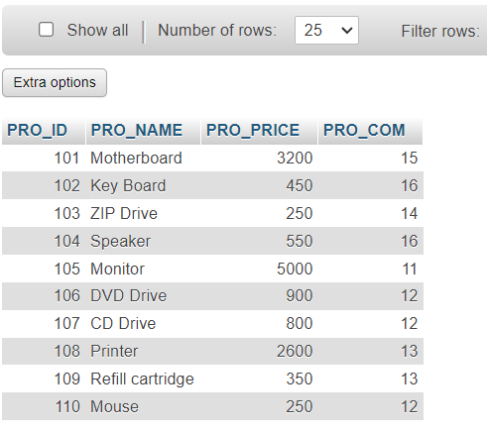

1. From the following table, write a SQL query to select a range of products whose price is in the range Rs.200 to Rs.600. Begin and end values are included. Return pro_id, pro_name, pro_price, and pro_com

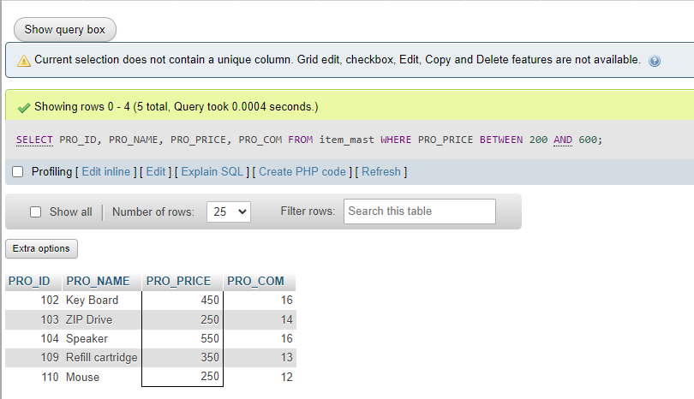

1. From the following table, write a SQL query to calculate the average price for a manufacturer code of 16. Return avg.

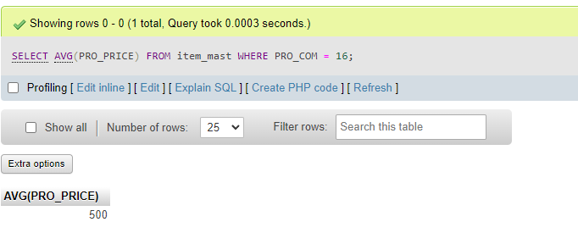

1. From the following table, write a SQL query to display the pro_name as 'Item Name' and pro_price as 'Price in Rs.'

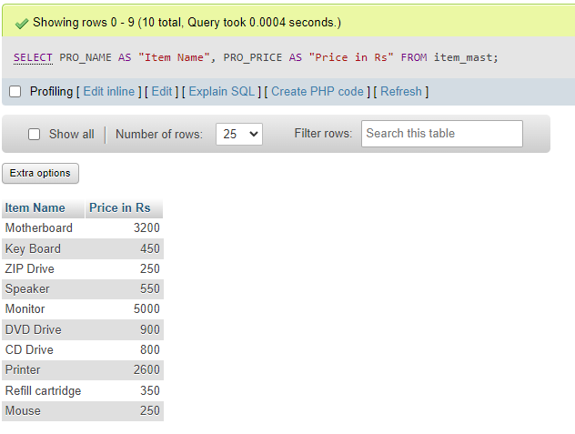

23.From the following table, write a SQL query to find the items whose prices are higher than or equal to $250. Order the result by product price in descending, then product name in ascending. Return pro_name and pro_price.

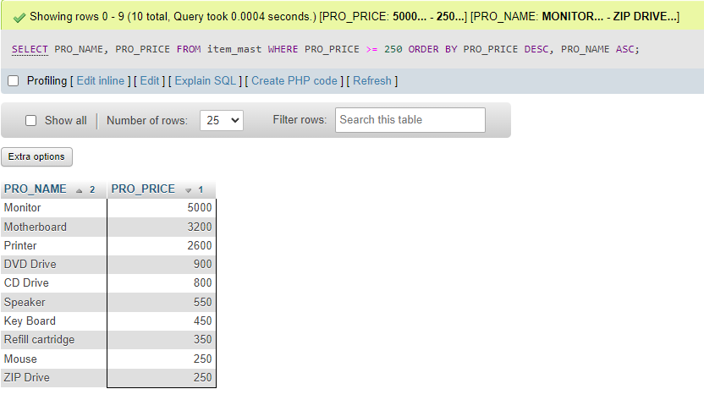

24.From the following table, write a SQL query to calculate average price of the items for each company. Return average price and company code.

